**A Brief Survey on Some Latest Work in Ridesharing and Ridesharing in Social Network**

# Introduction

Ridesharing, or shared transportation, allows people to use private transport resources in a much more flexible, clever, and effective way. Two characters are often involved in this period. The first is driver, while the second is passenger. By using his or her own car, the driver can pick up orders from passengers, drive them to the destination, and gain benefits, generally considered as revenue. On the other side, the passengers can reach their destinations without purchasing private cars, and can even share a trip with other passengers, which again enlarges the utility of private vehicles.

After 2014, the research on ridesharing becomes much more complex and the aspect of ridesharing has become larger than before. The entropy of keywords has increased, and the quantity of articles in this field has increased exponentially. However, there are still new areas within to be explored. According to **[1]**’s investigation, dynamic networks, routing, location problem, social network, and collaborative consumption are all hot topics currently. This trend shows the public concern on social relationship and its interaction instead of pure optimization problem. While with the development of those large ridesharing platforms such as DiDi and Uber, social safety and trust between driver and passengers has become a new problem. Some of them focus on the problem definition or platform (**[2]**), while some of them focus on algorithms and simulation (**[3, 4]**).

Since the diversity of objective function, there are many topics about ridesharing in literature. Some researches aim to minimize the total travel cost of all vehicles to potentially reduce the pollution and congestion status, while some focus on minimizing the waiting time of the passengers **[5]**. Also, all these objectives can be combined together to find a better solution for all people **[6, 7, 8]**. Either way, there are many factors to consider. If certain factors are considered as the objectives, then the others could be considered as the constraints (e.g., if a problem doesn't aim to reduce the passengers' detour, then the detour tolerance of the passenger could be a constraint).

**[9]** lists several algorithms including the exact method, heuristic method and meta heuristic method presented in several research fields like operation research, database, transportation and artificial intelligence. All these algorithms have a common operation: insert a new request to a vehicle's schedule. **[10]** concludes that this is a core operation named "insertion operator" in dynamic ridesharing and presenting a more efficient insertion operator helps reduce the computation cost. **[11]** presents a solution with a new perspective: Make route plan with detour instead of shortest path to maximize the expected number of compatible passengers in a single tour. There are also interesting ideas like **[12]**, which proposes a greedy and a ranking approach for order dispatch and their corresponding pricing strategies, to maximize the overall utility of the auction, while ensuring desirable auction properties such as truthfulness and individual rationality, in the situation of shortage of vehicles. With new technologies advancing, **[13]** collects a set of researches concerning ridesharing using an Autonomous Vehicle Systems, potentially integrated with electricity power usage.

In our project, we are going to explore how the social network works in ridesharing based on existing methodology to solve a practical problem which is the lack of vehicle in rush hour. We are going to find an algorithm to solve it and develop a simple simulator to evaluate our solution.

# Why Is Social Network Involved?

**[5]** mentioned that building trust among unknow passengers in online systems is a major challenge in shared mobility system. A clear trend for commuters in the same building is to form a shared mobility community to reduce transportation cost by sharing vehicles with friends (people close in the social network) **[14]**. Searching ridesharing groups based on communities would make ridesharing services more convenient, safer and attractive to the users **[15]**. Ridesharing with friends is a more acceptable solution for people who don't like to share vehicles with strangers and will be potentially more acceptable by more people **[16]**.

**[17]** illustrates another reason. The relationship between friends can affect ridesharing, because they often share a similar initial position or destination. Meanwhile, this paper shows that the more friends a traveler has, the larger the number of travelers who are willing to use shared transportation is. This may further reduce the travel cost and enhance the advantages of ridesharing.

# Existing Approaches of “Ridesharing in Social Network”

In artificial intelligence research field, this problem is formulated as a Graph Constraint Coalition Formation problem and solved by an approximate method using branch and bound **[14]**. To ensure the information of users are kept secret only to other passengers close to them, **[15]** develops a CaRG (Community-aware Ridesharing Group) query to enhance the security level of information flowing in the ridesharing procedure, as well as reduce the cost by avoiding unnecessary computations. **[18]** considers even more to make sure the passengers enjoy the most. In this paper, not only social relationship matters, but also vehicle quality and even sceneries along the trip. All these factors are considered as utilities for passengers, and are categorized into three sections: vehicle-related utility, rider-related utility (rider as passengers) and trajectory-related utility. To maximize the passengers’ overall utility, the authors first formulate an NP-hard problem – URR (Utility-aware Ridesharing on Road Networks), then propose assignment method as well as three efficient approximate algorithms to assign passengers to suitable vehicles with a high overall utility, subject to spatial-temporal and capacity constraints.

Although there are already some existing approaches in this field, the algorithms might not be able to fit the needs from one another, since the objectives and constraints we pick could be different, and our solution set could be more than one possibly. Therefore, there is also huge space for us to discover more in this area.

# Problem Definition

**Ridesharing Problem**

A map contains several nodes and edges. The nodes represent the locations on map which can be marked as starting points (waiting position for passenger) and destinations, denoted as v. The edges are streets and connect the nodes, the edges are associated with distance, and edges are directed since the distance computed from different direction might not be the same. Two characters are moving on map: vehicles and passenger. Each vehicle has a schedule which consists a sequence of locations the vehicle passed by or is going to pass by.

**Social Network**

Besides the classical ridesharing problem, another concept taken as a constraint is the social network. The connection through network means that two nodes are "friends". A passenger can only be matched to his/her direct friends and people in some social group he/she participates in. For example, as shown in the figure below, "me" knows "Peter", but "me" doesn't know A and B, but "me", A and B are in the same social group which is "iPark A7". Thus "me" can be matched with Peter, A or B.

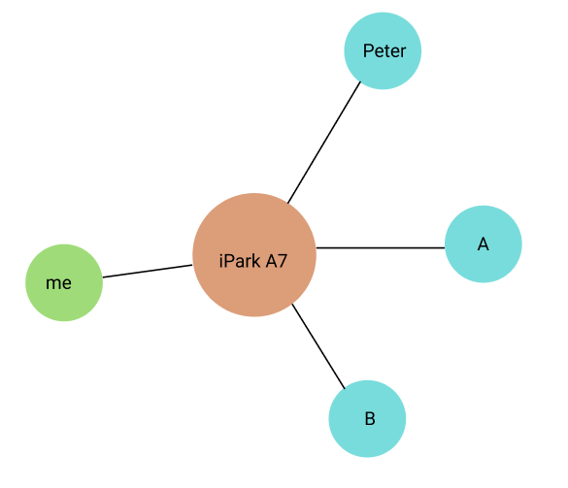

**Dynamic Ridesharing**

A list of requests from passenger will be handled by the ridesharing matching system. If a request is handled, the passenger sending this request will be assigned to a working vehicle nearby. Before the passenger arriving at the destination, the vehicle can also handle other requests, if those requests' sender can be matched with passengers already in the vehicle.

We use a **directed** weighted graph to represent the street network: $G=(V,E,w)$, where $V$ is a set of vetices of the graph representing specific locations in the street network, E is a set of edges $e=(u,v)$ connecting vetices in $V$, representing a path between two locations $u$ and $v$, and $w : e→c$ is a weight function whose input is a path $e$ and output is the travel cost $c$ of the path.

Passenger $p_{k}$'s feasible matching passenger list is represented as: $l_{k}=\{p_{i},…,p_{j}\}$.

A request r contains four information: $r_{i}=(p_{i},v_{s_{i}},v_{d_{i}},t_{r_{i}})$, where $p_{i}$ is passenger $i$, $v_{s_{i}}$ is the position where $p_{i}$ is waiting for a vehicle, $v_{d_{i}}$ is the position of $p_{i}$'s destination, and $t_{r_{i}}$ is the requests's sending time. Real time: the request is invisible to the system if current timestamp is smaller than $t_{r_{i}}$.

A vehicle's schedule s is represented by an ordered sequence of positions: $s=\{v_{s_{i}},…v_{d_{i}}\}$, where the elements $v$ are waiting positions or destinations of its handling requests and the waiting position of a request should be placed in front of the destination of this request.

**DEFINITION 1** A schedule is $feasible$ if 1) the waiting time for a passenger is smaller than the maximum waiting time $T$, and the travel distance of every request $r$ handled by this schedule is smaller than $\left(1+α\right)σ(r)$, where $α$ is the detour tolerance factor and $σ(r)$ is the distance of the shortest path between the waiting position and destination in $r$.

For example, as shown in (figure 1), passenger 1 and passenger 2 are in the same group and can share a same vehicle. And they share a same destination (6). Assume all the edges are weighted $w:1→1$. The schedule of vehicle should be $s=\{1,2,3,4,6\}$ and detour factor of passenger 1 should larger than $0.5$ and not limited for passenger 2.

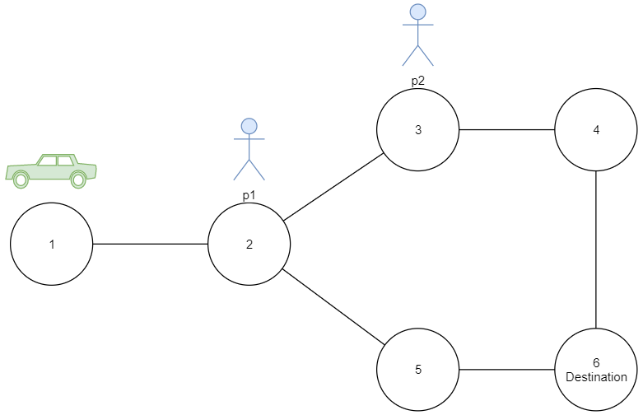

figure

We aim to **maximize the percentage of handled requests**, which is denoted by $P(S)$, the objective function is: $\max_{S∈A}{P(S)}$, where $S$ is a set of $feasible$ schedules of all vehicles, $A$ is all the possible schedule sets.

# Baseline

The response time for every request should be acceptable for a real time system. This requires good performance of the algorithm. The quality should also be guaranteed, which can be measured by several ways: 1) calculate the exact solution and compare our solution with the exact solution. 2) compare our method with the existing method. 3) run a simulation and examine whether the percentage of handled requests is acceptable or not.

The constraint of social network can lead to failure in matching algorithm and may cost additional detours. Meanwhile, ridesharing with friends in social network can also lead to higher aspiration in shared transportation. Thus, the final cost in traffic may be reduced.

In order to compare the differences, we plan to do the benchmark through running simulations and algorithms in 2 different environments: (1) using original constraint and match passengers and drivers, (2) adding social network as a constraint and test the result under distance less than 2, 3, and 4.

Our test can use road network data of Manhattan city along with order data from DiDi, the social network can be generated by scale-free network **[19]** and assigned to each order.

# Source Data

* <http://snap.stanford.edu/data/#socnets>： Social Networks, Road Networks
* <https://www.openstreetmap.org/>: Road Networks
* <https://chriswhong.com/open-data/foil_nyc_taxi/>: NYC's Taxi Trip Data
* <https://socnetv.org/> : Social Network Visualizer - generate small dataset of social network

# References

[1] Z. Sun, Y. Wang, H. Zhou, J. Jiao and R. Overstreet, "Travel behaviors, user characteristics, and social-economic impacts of shared transportation: a comprehensive review", International Journal of Logistics Research and Applications, pp. 1-28, 2019. Available: 10.1080/13675567.2019.1663162.

[2] H. Wang and H. Yang, "Ridesourcing systems: A framework and review", Transportation Research Part B: Methodological, vol. 129, pp. 122-155, 2019. Available: 10.1016/j.trb.2019.07.009.

[3] D. Bertsimas, P. Jaillet and S. Martin, "Online Vehicle Routing: The Edge of Optimization in Large-Scale Applications", Operations Research, vol. 67, no. 1, pp. 143-162, 2019. Available: 10.1287/opre.2018.1763.

[4] Held, Maximilian & Küng, Lukas & Çabukoglu, Emir & Georges, Gil & Pareschi, Giacomo & Konstantinos, Boulouchos. (2018). Future mobility demand estimation based on socio-demographic information: A data-driven approach using machine learning algorithms. 10.3929/ethz-b-000266653.

[5] 2018 trb - Mourad, Abood & Puchinger, Jakob & Chu, Chengbin. (2019). A survey of models and algorithms for optimizing shared mobility. Transportation Research Part B: Methodological. 10.1016/j.trb.2019.02.003.

[6] Y. Tong, Y. Zeng, Z. Zhou, L. Chen, J. Ye and K. Xu, "A unified approach to route planning for shared mobility", Proceedings of the VLDB Endowment, vol. 11, no. 11, pp. 1633-1646, 2018. Available: 10.14778/3236187.3236211.

[7] P. Cheng, C. Feng, L. Chen and Z. Wang, "A Queueing-Theoretic Framework for Vehicle Dispatching in Dynamic Car-Hailing," 2019 IEEE 35th International Conference on Data Engineering (ICDE), Macao, Macao, 2019, pp. 1622-1625.

[8] L. Chen, Q. Zhong, X. Xiao, Y. Gao, P. Jin and C. S. Jensen, "Price-and-Time-Aware Dynamic Ridesharing," 2018 IEEE 34th International Conference on Data Engineering (ICDE), Paris, 2018, pp. 1061-1072.

[9] James J. Pan, Guoliang Li, and Juntao Hu. 2019. Ridesharing: simulator, benchmark, and evaluation. Proc. VLDB Endow. 12, 10 (June 2019), 1085–1098. DOI:https://doi.org/10.14778/3339490.3339493

[10] Y. Xu, Y. Tong, Y. Shi, Q. Tao, K. Xu and W. Li, "An Efficient Insertion Operator in Dynamic Ridesharing Services," 2019 IEEE 35th International Conference on Data Engineering (ICDE), Macao, Macao, 2019, pp. 1022-1033.

[11] Chak Fai Yuen, Abhishek Pratap Singh, Sagar Goyal, Sayan Ranu, and Amitabha Bagchi. 2019. Beyond Shortest Paths: Route Recommendations for Ride-sharing. In The World Wide Web Conference (WWW ’19). Association for Computing Machinery, New York, NY, USA, 2258–2269. DOI:<https://doi.org/10.1145/3308558.3313465>

[12] L. Zheng, P. Cheng and L. Chen, "Auction-Based Order Dispatch and Pricing in Ridesharing," 2019 IEEE 35th International Conference on Data Engineering (ICDE), Macao, Macao, 2019, pp. 1034-1045.

[13] L. Zhao and A. Malikopoulos, "Enhanced Mobility With Connectivity and Automation: A Review of Shared Autonomous Vehicle Systems", IEEE Intelligent Transportation Systems Magazine, pp. 0-0, 2020. Available: 10.1109/mits.2019.2953526.

[14] Filippo Bistaffa, Alessandro Farinelli, and Sarvapali D. Ramchurn. 2015. Sharing rides with friends: a coalition formation algorithm for ridesharing. In Proceedings of the Twenty-Ninth AAAI Conference on Artificial Intelligence (AAAI’15). AAAI Press, 608–614.

[15] Samiul Anwar, Shuha Nabila, and Tanzima Hashem. 2017. A Novel Approach for Efficient Computation of Community Aware Ridesharing Groups. In Proceedings of the 2017 ACM on Conference on Information and Knowledge Management (CIKM ’17). Association for Computing Machinery, New York, NY, USA, 1971–1974. DOI:<https://doi.org/10.1145/3132847.3133117>

[16] Y. Wang, S. Winter and N. Ronald, "How much is trust: The cost and benefit of ridesharing with friends", Computers, Environment and Urban Systems, vol. 65, pp. 103-112, 2017. Available: 10.1016/j.compenvurbsys.2017.06.002.

[17] P. Thaithatkul, T. Seo, T. Kusakabe and Y. Asakura, "Adoption of dynamic ridesharing system under influence of information on social network", Transportation Research Procedia, vol. 37, pp. 401-408, 2019. Available: 10.1016/j.trpro.2018.12.209.

[18] Peng Cheng, Hao Xin, and Lei Chen. 2017. Utility-Aware Ridesharing on Road Networks. In Proceedings of the 2017 ACM International Conference on Management of Data (SIGMOD ’17). Association for Computing Machinery, New York, NY, USA, 1197–1210. DOI:<https://doi.org/10.1145/3035918.3064008>

[19] Choromanski, Krzysztof & Matuszak, Michał & Miekisz, Jacek. (2013). Scale-Free Graph with Preferential Attachment and Evolving Internal Vertex Structure. Journal of Statistical Physics. 151. 10.1007/s10955-013-0749-1.